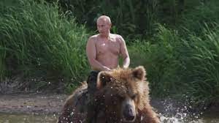Flag is

lbctf{rockymeadows}

WHaT dO yOu ThiNK ThE BEAR ThouGHT?